# Styling lists:

To create a navbar with list items do this in html:

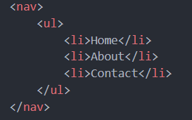

If you inspect a single list element it’s like this

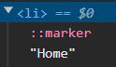



We have seen this before like display: inline etc.

**list-item** as display property means that it has one marker and one item

## list-style:

using this we can change the marker of each list item.

For ex..



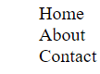



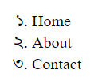

If you change background color of a list element:

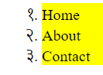

As we can see marker remains uncolored

This means the marker is out of the list item

This can be resolved by doing



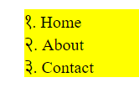

We can replace maker with an image or emoji

list-style-image: url(“”)

list-style-type(🎶)

Using list style we can do multiple of these together

To make this horizontal:

We add display:flex to ul (parent of li)

We put some padding for li (optional)

